Week5_Day2_Assignment_Restful-Booker

Create a new booking

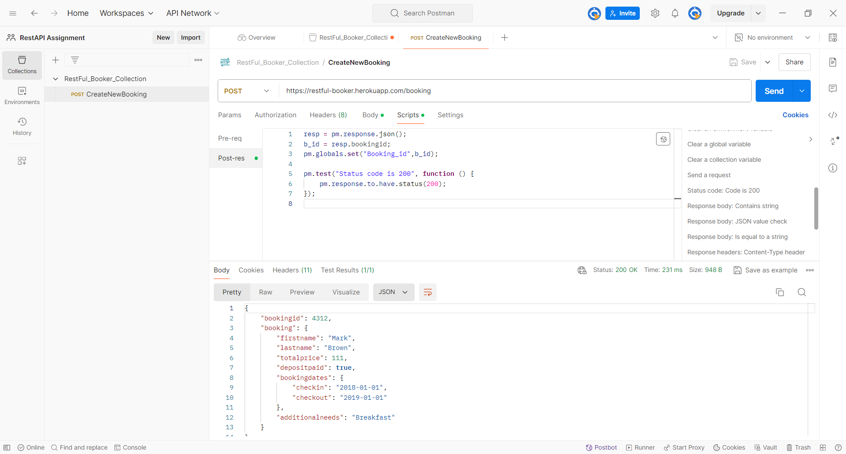

Search Booking based on Booking ID

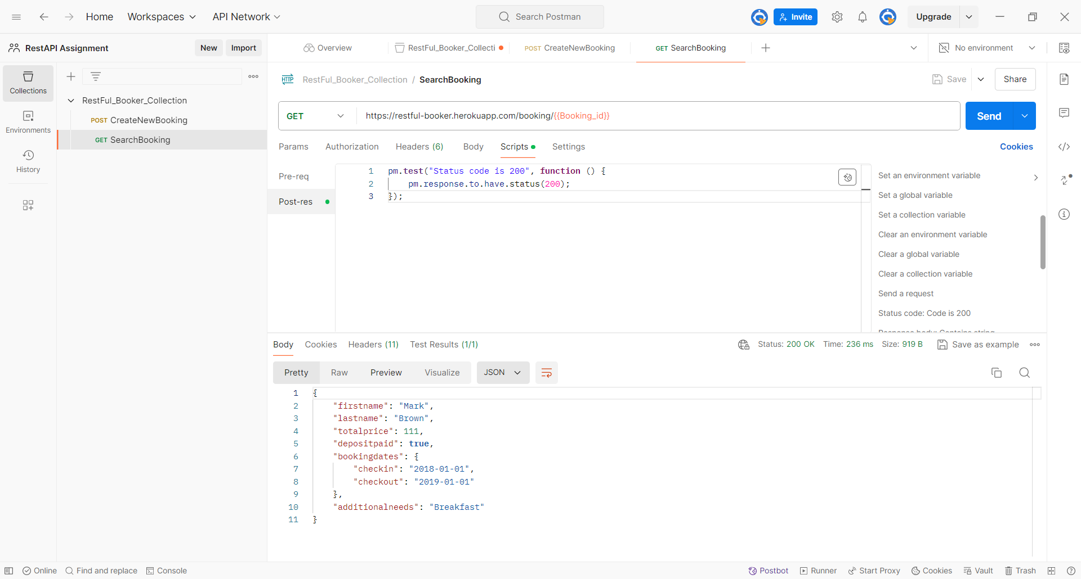

Edit a Booking (Based on Booking ID)

